Chapter 6 Results and analysis
Based on the simulation results of the two-hop direct V2X communication over side link. We can analyse the performance of the communication system and prove the results to be positive. We employ several results tables.
6.1 The performance comparison of the single-hop and two-hop communication
Inter-vehicle-distance=10 meters
$${BW}_{1}$$ | $${BW}_{2}$$ | Packet Reception Ratio
5 MHz | No | 39.67%
6 MHz | No | 45.74%
8 MHz | No | 54.26%
10 MHz | No | 56%
5 MHz | 5 MHz | 77.72%
6 MHz | 4 MHz | 77.31%
8 MHz | 2 MHz | 90.90%
Table 1: system performance of different resource allocation schemes with 10-meter inter vehicle distance
In Tab.1, the inter-vehicle-distance is set to be 10 meters. ${BW}_{1}$ and ${BW}_{2}$ are the amount of resources allocated to the first and second hops respectively. And the packet reception ratios of the different allocation schemes have given. In case that no resource is allocated to the second hop, so the only single hop direct V2X communication is also used here and we can use the results of the single-hop direct V2X communication to compare the two-hop direct V2X communication. From the table, it is clear to find that single-hop direct V2X communication have lower packet reception ratio, since the single hop cannot fulfil the 1000-meter transmission range requirement.
An efficient way to increase the performance of the single-hop communication system is to increase the transmission bandwidth. As Eq. (22)

$SE≥C/BW$ (22)
As Fig. shows, with increased bandwidth, the required spectral efficiency of the transmission has been decreased. Therefore, a MCS with a better robustness can be applied in this case and the transmission range have been improved. For example, the 10 MHz transmission range of the first hop is clearly larger than the transmission range by using 6MHz. And from the simulation results, the spectral efficiency is decread with the increased bandwidth. Which are 3.3223 and 5.1152 of 10 MHz and 6MHz correspondently.
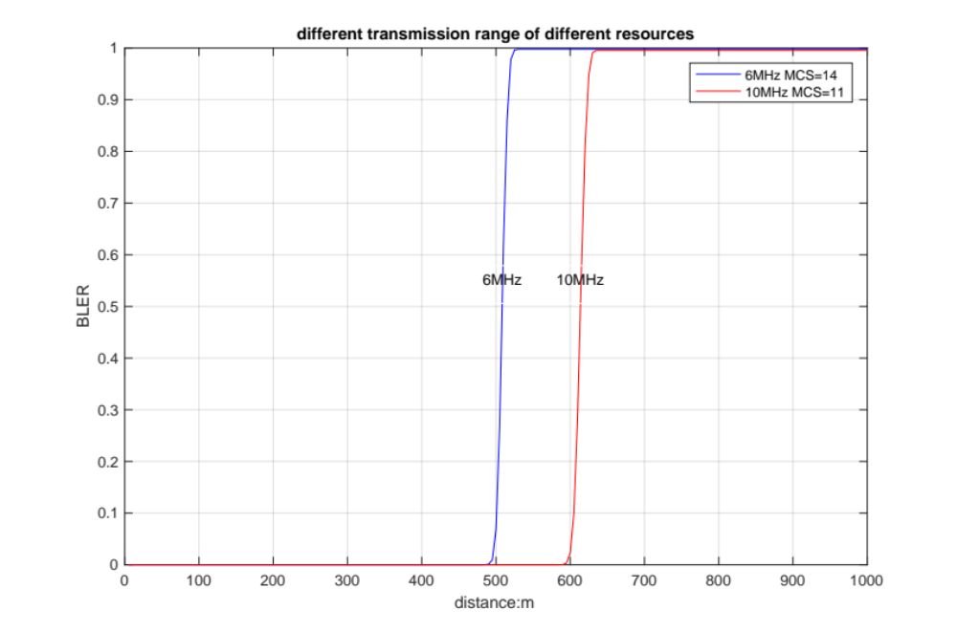
Figure : The different transmission range of single-hop under different resources and MCSs
6.1.1 the performance of two-hop communication by allocating the 10MHz
Another efficient way proposed to increase the transmission range and to increase the performance of the communication systems is two-hop direct V2X communication, which can use the frequency resources in an efficient manner. From Fig. 10, if the 10 MHz is used only in the single-hop direct V2X communication, the packet reception ratio is about 56%. But if we apply the two-hop direct V2X communication with the same amount of bandwidth, the transmission range can be efficiently improved.
For example, we allocate 8 MHz and 2 MHz, 6MHz and 4MHz, and 5MHz and 5MHz to the first hop and second hop respectively. 5MHz for the first hop and 5MHz for the second hop provides the best performance of the communication system, which increases the packet reception ratio from 56% to 77.72%. it is also deserved to note the packet reception ratio of 77.72% in the two-hop transmission scheme which is to allocate 5MHz for the first hop and 5 MHz for the second hop is slightly lower than two times of the packet reception ratio of 39.67% in the single-hop direct V2X communication with 5MHz bandwidth. This is due to the strongest interference in the second-hop transmission is from the other relay vehicle which transmits the same packets by using the same bandwidth.
6.1.2 The interference in the first and second hop
The interference in the first hop transmission is from a transmitter which is served by another base station. And the distance between the two close transmitters using the same bandwidth resource has statistically an average value of 6000 meters in the considered highway scenario.
However, the distance between the two relay vehicles transmitting the same packets by using the same resource is lower than two times of the communication range of 2000 meters.
Therefore, the second hop can experience a higher interference power density than the first hop.
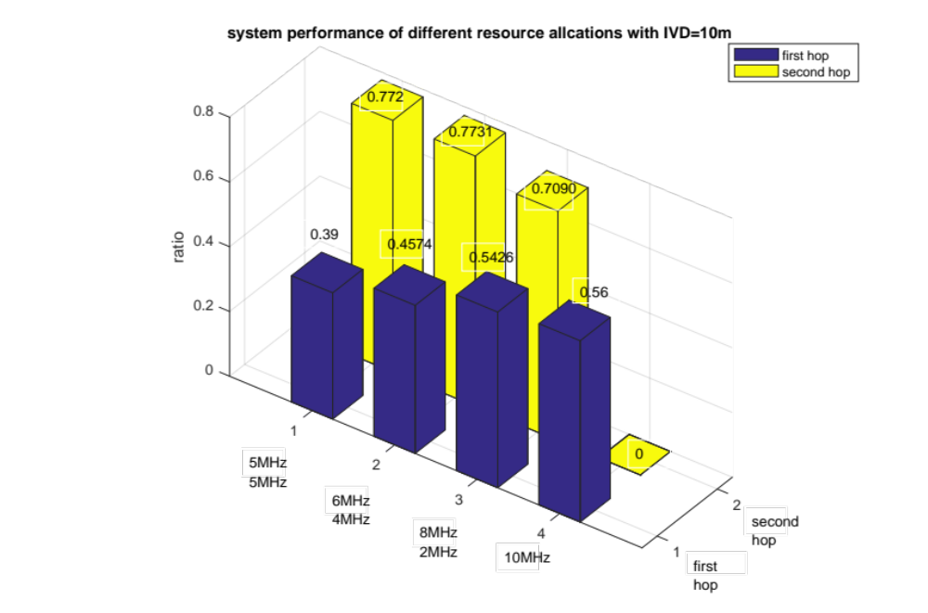
figure 10: System performance of different resource allocation scheme with 10 metres inter-vehicle-distance
6.2 The performance comparison of different inter-vehicle-distance

Inter-vehicle-distance=15 meters
$${BW}_{1}$$ | $${BW}_{2}$$ | Packet Reception Ratio
5 MHz | No | 54.26%
6 MHz | No | 57.54%
8 MHz | No | 67.02%
10 MHz | No | 71.28%
5 MHz | 5 MHz | 100%
6 MHz | 4 MHz | 99.82%
8 MHz | 2 MHz | 84.93%
Table 2: system performance of different resource allocation schemes with 15-meter inter vehicle distance
In Tab.2 the packet reception ratios are higher than those values in the Tab.1. The reason is the inter-vehicle-distance is increase from 10 meters to 15 meters, which means low density of vehicles mapped on the highway compared to the precious one. A MCS with better robustness can be applied. As Fig.12 shows, we take the 10 MHz only used in the single-hop transmission with a 10-meter IVD and a 15-meter IVD respectively. The transmission range is obviously increased. And the spectral efficiency has increased from 3.3223 to 2.4063. That is why the packet reception ratios in the Tab.2 are always better than those values in the Tab.1.
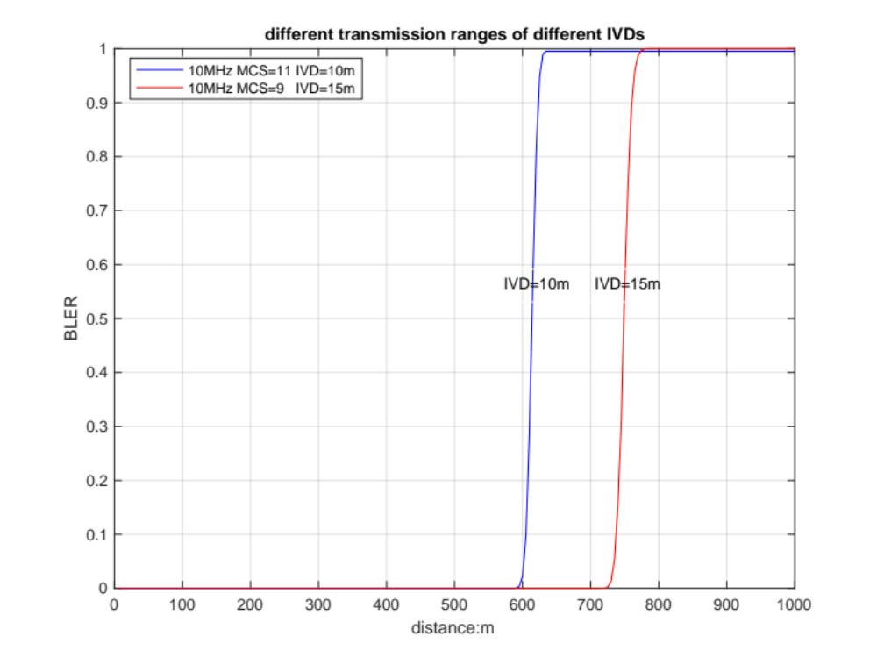
Figure.12 The different transmission ranges of different IVDs
In addition, the packet reception ratio of the single-hop direct V2X communication with 15 meters IVD by using 10 MHz is 71.28%, which can be increased to 100% by applying 5MHz for the first hop and 5MHz for the second hop.
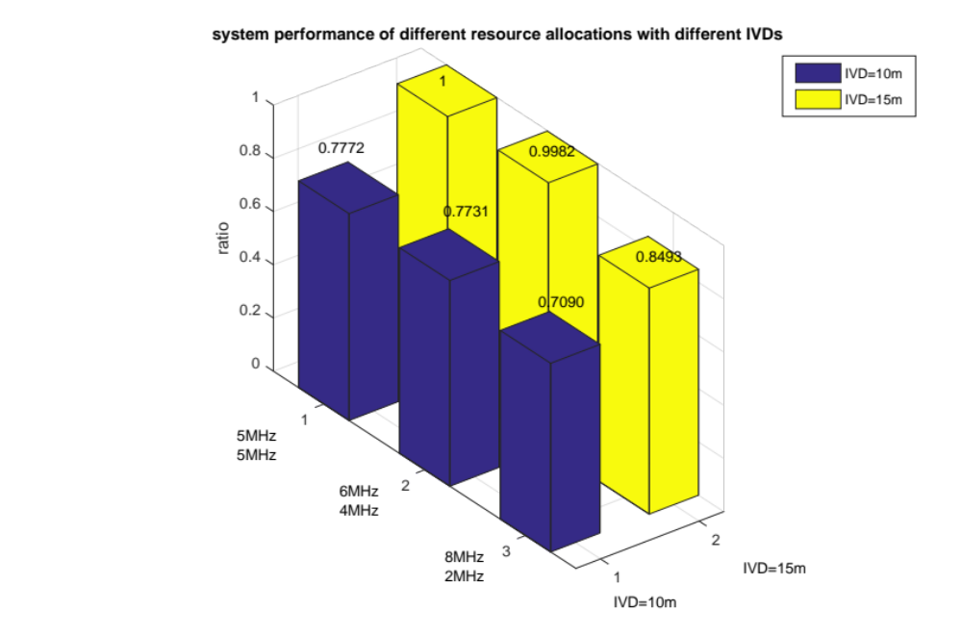
Figure 13: System performance of different resource allocation scheme with different inter-vehicle-distance
By comparing Fig.10 and Fig.13, we can find that 5MHz for the first and 5MHz for the second hop transmission always have the best performance compared to other resource allocation schemes. As mentioned in chapter 4, when ${BW}_{1}={BW}_{2}$, the transmission range is maximized. That is why equal resource allocation scheme has a better performance than other resource allocation schemes.
6.3 Different resource allocation schemes for the second hop
In Tab.3, the total bandwidth is 20 MHz and 10MHz of the bandwidth is allocated to the first hop. So the performance of the different scheme should be same. We need to consider more about the resource allocation in second hop direct V2X communication. The left 10 MHz bandwidth is allocated to the second hop. As mentioned in chapter 5, we have simply introduced the inference in the second hop.
The first allocation scheme is 10 MHz bandwidth allocated to the second hop and the two relays transmit the same packet over the same resource. Thus, the strongest mutual interference for the second hop is introduced by the other relay which transmits the same packets.
The second allocation scheme is 10 MHz divided into two sub-bands for the two relays in the second hop. So each relay transmits the same packet over the different sub-band. Therefore, there is no mutual interference between the two relays transmitting the same packet.
In Tab.3, the packet reception ratio of the first allocation scheme is 99.98% which is slightly larger than the packet reception ratio of the second allocation scheme. The reason is that less resource allocated to the second hop transmission and a MCS with a worse robustness needs to be used. Even though the interference power in the second hop is lower than the interference power in the first hop transmission.
Inter-vehicle-distance=10 meters
$${BW}_{1}$$ | $${BW}_{2}$$ | Packet Reception Ratio
10 MHz | Multiplex 10 MHz | 99.98%
10 MHz | 5 MHz + 5 MHz | 95.90%
Table 3: system performance comparison of different resource allocation schemes for the second hop transmission with 10-meter inter vehicle distance

